Assignment 1 – Docker – I
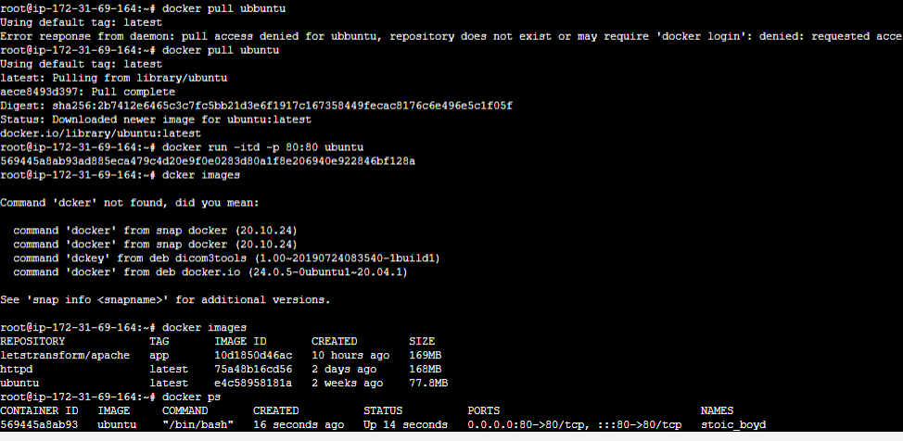
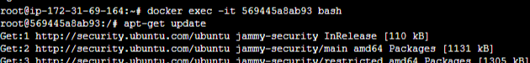
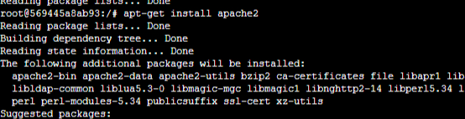
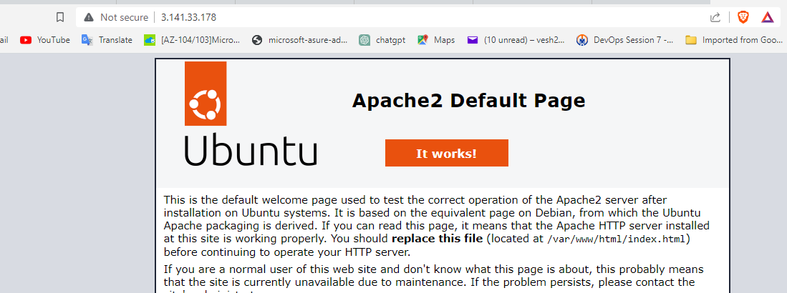
==================================================================================

Assignment 2 – Docker – I
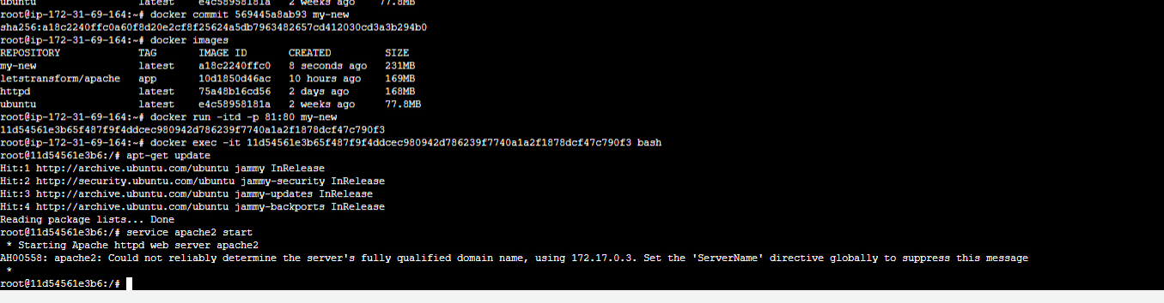
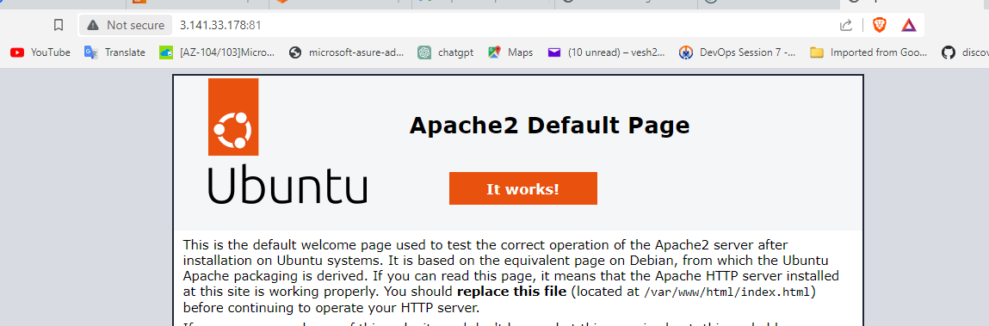
==================================================
Assignment 3 – Docker – I
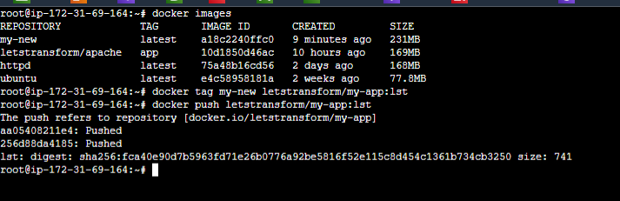
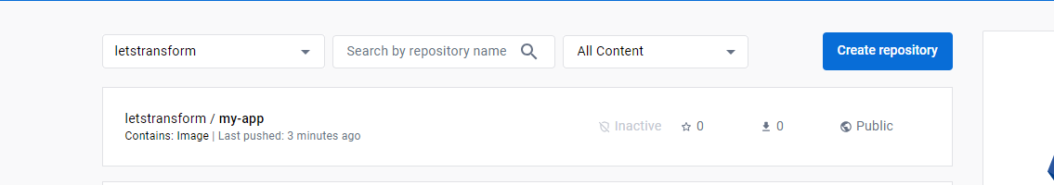
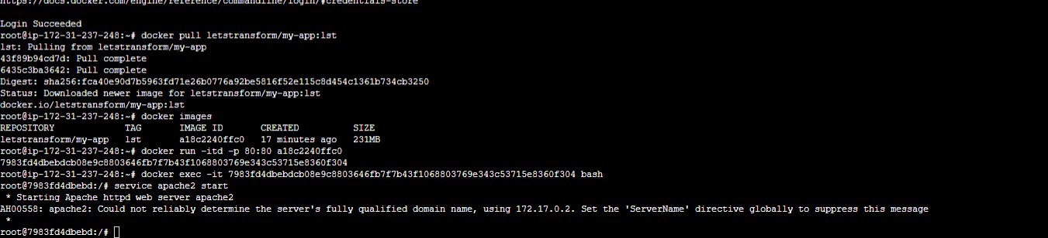
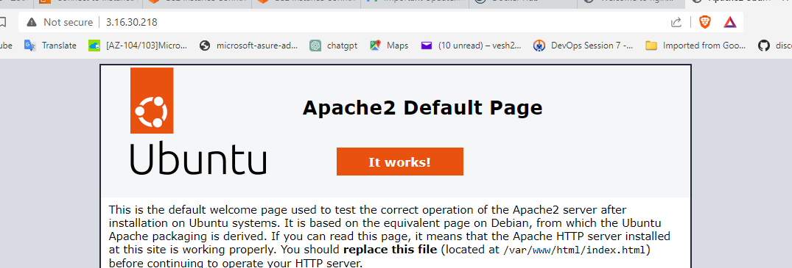
==================================================
Assignment 4 – Docker – I
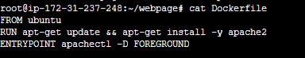
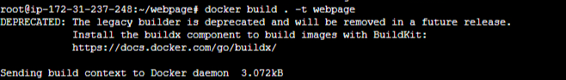
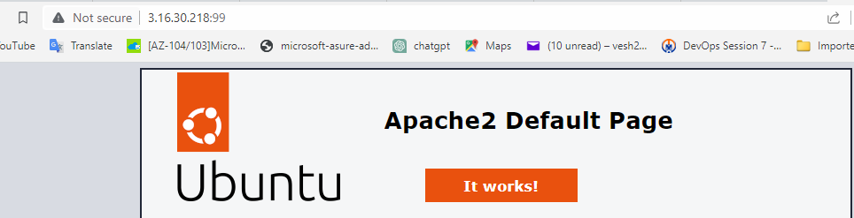
==================================================
Assignment 5 – Docker – I
